**LINUX: Exercises about files manipulation**

**Part 1**

Create a file called “awards” in your home directory, containing

JESSE#EISENBERG#THE SOCIAL NETWORK#ACTOR

COLIN#FIRTH#THE KING’S SPEECH#ACTOR

HALLE#BERRY#FRANKIE AND ALICE#ACTRESS

NATALIE#PORTMAN#BLACK SWAN#ACTRESS

DARREN#FINCHER#THE SOCIAL NETWORK#DIRECTOR

ANNETTE#BENING#THE KIDS ARE ALRIGHT#ACTRESS

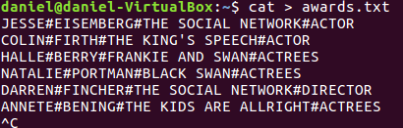

1. Add a new line, containing CHRISTOPHER#NOLAN#INCEPTION#DIRECTOR, at the end of the file. You should complete this exercise using commands instead of file editors.

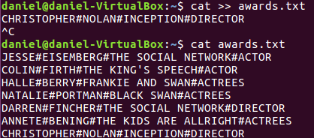

1. Create a file called “actors” in which you only include ACTORS
2. 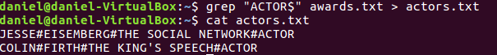

Display the files which begin with a in your home directory



1. Create a file called “directors” in which you only include DIRECTORS

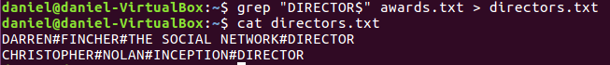

1. Display the lines of “awards” containing actresses. Show the line number.



1. Display the lines in “awards” which are not directors. Show the line number.



**Part 2**

Create the file called “people.txt”

Ana;Perrrrrrrales;1000

Pedro;Soria;1600

Jacinto;Manzano;500

Claudia;Pastor;600

Xavier;Granados;1000

Soraya;Annnnnnnneja;3000

Xavier;Guerra;4500

Sara;Siria;675

Pablo;Serrano;1000

Sonia;Mono;1600

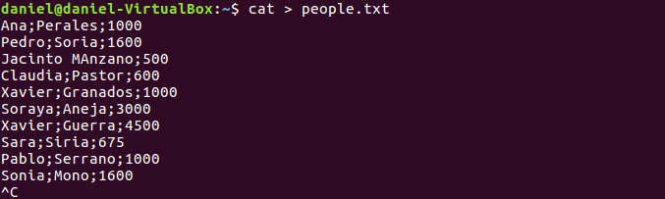

1. Create a file called “people2.txt”, containing those people whose name begins with J or S.

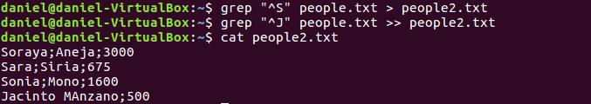

1. Create a file called “people3.txt”, containing those people whose names do not begin with S

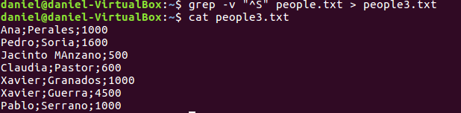

1. Display people whose name begin with S and redirect to file to “people_s.txt”

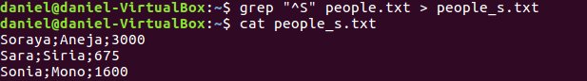

1. Display the number of people whose name begins with A (case insensitive).



1. Display how many people earn 1000 and concatenate the result in people2.txt



**Part 3**

1. Create a file called list, including the contents from the current directory



1. Open the file to check if the content is right using cat, more and less and observe the differences

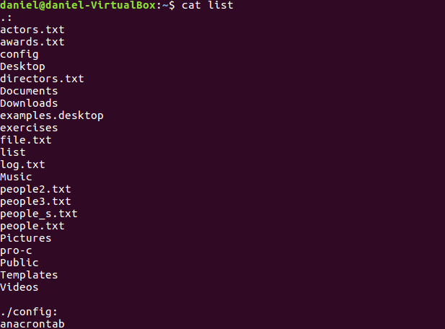

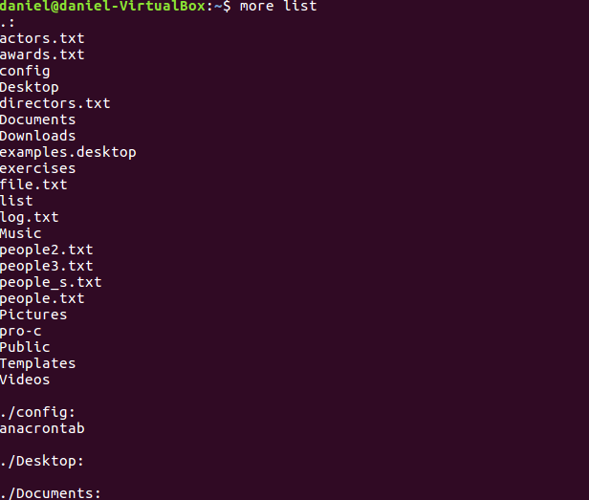

The more command displays a 23% and to see the other parts, press enter

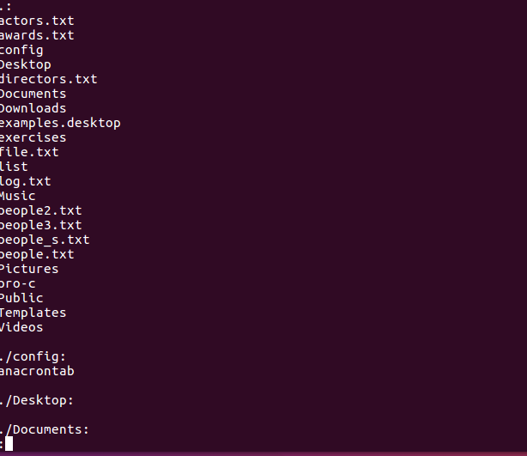

The less command it’s like more, except it has a few extra features

1. Print the contents of the current directory in reverse alphabetical order.

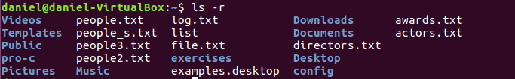

1. Create a file called inform, containing the long format list of the files and directories in your home directory

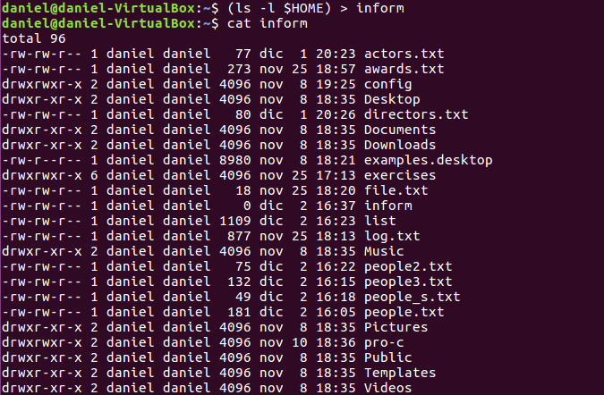

1. Find the word FILE in each file of your home directory, ignoring case and showing the line number (create files containing this word if you want any match).

